**Introduction**

The New York City (NYC) Rolling Sales dataset is an important dataset for the study of real estate sales in the five boroughs namely: Manhattan, Brooklyn, , The Bronx, and Staten Island. It is compiled and published by the NYC Department of Finance and offers a comprehensive record of property sales, including basic information like the address, neighborhood, sale price, sale date, building type, square footage, and land use category. This database is a useful tool for real estate industry professionals, Queens government policymakers, research analysts, and investors interested in grasping the forces behind New York's property market.

|  |  |
| --- | --- |
| **Borough Code** | **Borough Name** |
| 1 | Manhattan |
| 2 | The Bronx |
| 3 | Brooklyn |
| 4 | Queens |
| 5 | Staten Island |

*Table 1: Borough Representation*

Additionally, the NYC Rolling Sales dataset's primary purpose is to provide stakeholders with important information on real estate transactions and to maintain transparency in the real estate market. The dataset guarantees that the public has access to current and trustworthy real estate information by routinely documenting and making property sale data available. This transparency allows investors, buyers, and sellers to base their choices on current market trends. The dataset is also used by municipal planners and policymakers to follow market trends, establish policies that promote equitable development and affordable housing, and assess property values. It is also used to support revenue planning and tax valuation. The NYC Department of Finance uses this data to determine property values for taxation. Accurate property value ensures equitable property taxation and sufficient revenue collection for the city to fund community initiatives, infrastructure development projects, and public services.

The property distribution across New York City's boroughs reveals significant disparities in real estate density. Brooklyn leads by a substantial margin with 24,047 properties, making it the borough with the highest concentration of real estate. Queens follows as the second most property-dense borough, containing 18,441 properties, while Manhattan ranks third with 14,439 properties. The Bronx shows a marked decrease in property count with 7,049 properties, less than half of Manhattan's total. Staten Island has the lowest property count among all boroughs, with just 6,011 properties, reflecting its more suburban character and lower population density. The data presents a clear north-south and east-west divide in property distribution, with the more populous outer boroughs of Brooklyn and Queens dominating the property landscape. This uneven distribution of properties across the five boroughs reflects historical development patterns, zoning regulations, and the varying population densities that characterize New York City's diverse urban landscape.

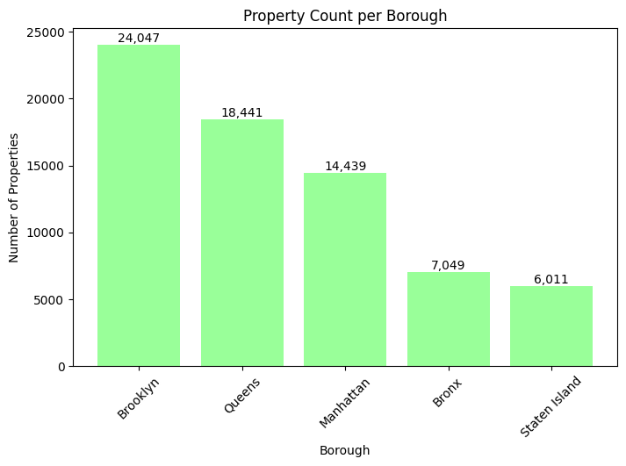

*Figure 1. Property Count per Borough*

**Sale Price and Percentage Increase or Decrease each Borough**

The graph below illustrates the steady increase in Brooklyn's average property sale prices from 2016 to 2017, showing a clear upward trend in the borough's real estate market. Starting at $806,441 in early 2016, the average sale price demonstrated consistent growth throughout the year. The linear progression of the trend line suggests a stable and predictable rate of appreciation in Brooklyn's property values during this period. By the end of 2017, the average sale price had reached $849,548, representing a significant increase of approximately $43,000 in just one year. This upward trajectory in property values reflects Brooklyn's growing attractiveness as a residential destination and its strong real estate market performance during this timeframe. The steady slope of the line, without any major fluctuations or disruptions, indicates a healthy and sustainable growth pattern in the borough's property market. The consistent price appreciation during this period suggests that Brooklyn remained an attractive investment opportunity for real estate buyers and developers, maintaining its position as one of New York City's most desirable boroughs.

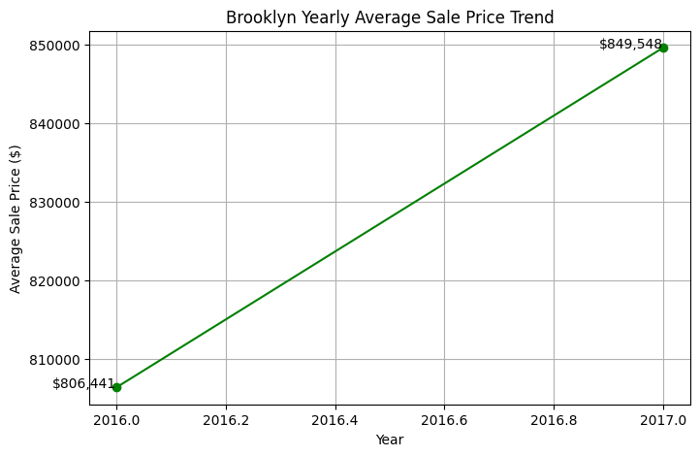

Figure 2. Brooklyn Yearly Average Sale Price Trend

The graph below depicts a notable downward trend in Queens' average property sale prices from 2016 to 2017, revealing a contrasting pattern to Brooklyn's market during the same period. Starting at a high point of $790,972 in early 2016, the average sale price in Queens experienced a steady decline throughout the year. The linear downward slope indicates a consistent decrease in property values, suggesting systematic market pressure rather than sporadic fluctuations. By the end of 2017, the average sale price had fallen to $712,793, representing a significant decrease of approximately $78,000 over the year. The continuous decline in prices might indicate changing market dynamics in Queens, possibly due to increased housing inventory, shifting buyer preferences, or broader economic factors affecting the borough. The steady downward trajectory, without any significant rebounds or plateaus, suggests that the market correction was persistent throughout this timeframe. This declining trend in Queens presents an interesting contrast to other parts of New York City's real estate market during the same period, potentially offering more affordable options for prospective homebuyers.

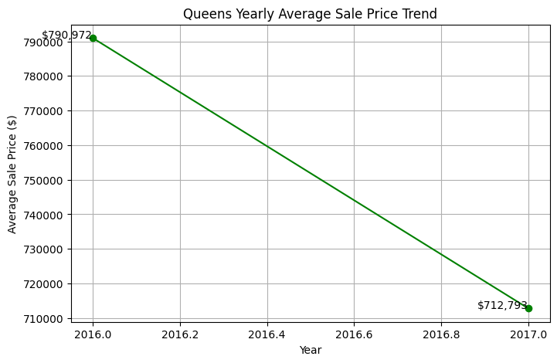

Figure 3. Queens Yearly Average Sale Price Trend

Manhattan's property market experienced a significant downturn in average sale prices between 2016 and 2017, as shown in the graph's clear downward trajectory. Beginning at a remarkable $3,636,798 in early 2016, the borough's average property prices underwent a steady decline throughout the observed period. The consistent negative slope suggests a systematic cooling of Manhattan's luxury real estate market during this timeframe. By the end of 2017, the average sale price had fallen to $3,192,209, representing a substantial decrease of approximately $444,589 over the year. Despite the decline, Manhattan's property values remained significantly higher than those in other boroughs, reflecting its status as New York City's premier real estate market. The linear nature of the decline, without any major fluctuations or interruptions, indicates a steady market correction rather than a volatile downturn. This trend might have been influenced by various factors, such as changes in foreign investment, market saturation in the luxury segment, or broader economic conditions affecting high-end real estate.

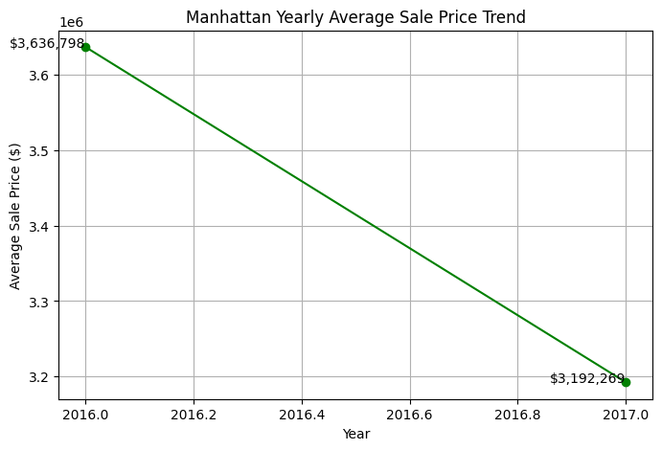

Figure 4. Manhattan Yearly Average Sale Price Trend

The Bronx borough graph demonstrated a positive trend in average property sale prices from 2016 to 2017, showing steady growth in this emerging real estate market. Starting at $573,634 in early 2016, the borough's average sale price exhibited consistent appreciation throughout the year. The linear upward progression indicates a stable and reliable increase in property values, suggesting growing interest in the Bronx's real estate market during this period. By the end of 2017, the average sale price had reached $598,938, representing a noteworthy increase of approximately $25,300 over the year. While the Bronx's property values remained lower than those in Manhattan and Brooklyn, the steady price appreciation indicates the borough's growing appeal to potential homebuyers and investors. The graph's consistent positive slope, without any significant dips or spikes, suggests a sustainable and healthy growth pattern in the local real estate market. This upward trend might reflect ongoing development initiatives, improved infrastructure, and increasing recognition of the Bronx as an affordable alternative to other New York City boroughs.

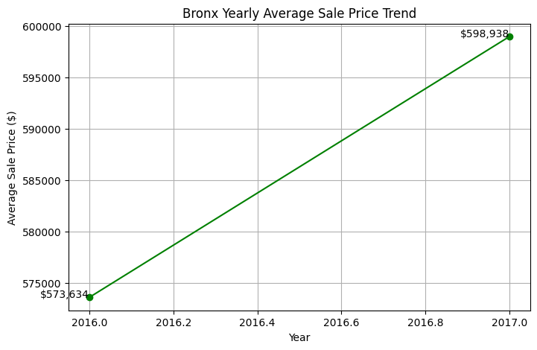

Figure 5. Bronx Yearly Average Sale Price Trend

Staten Island's real estate market showed a declining trend in average property sale prices from 2016 to 2017, following a pattern similar to Queens and Manhattan. The borough's average sale price started at $549,910 in early 2016 and experienced a steady decrease throughout the year. The linear downward trend indicates a consistent depreciation in property values, suggesting a broader market adjustment affecting this predominantly suburban borough. By the end of 2017, the average sale price had fallen to $539,819, representing a decrease of approximately $10,091 over the year. While the decline was less dramatic than in Manhattan or Queens, it still reflects changing market conditions in Staten Island during this period. The steady downward slope, without any significant variations, suggests a systematic rather than volatile market correction. Despite having the lowest property count among all boroughs, Staten Island maintained relatively stable prices compared to the more dramatic price fluctuations seen in other parts of New York City during the same timeframe.

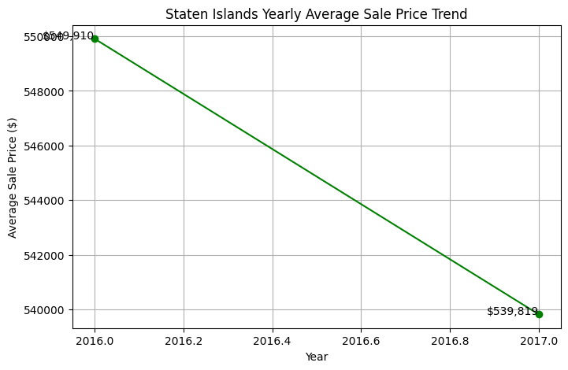

Figure 6. Staten Islands Yearly Average Sale Price Trend

The percentage changes in property sale prices across New York City's boroughs from 2016 to 2017 reveal a fascinating tale of market divergence. Manhattan experienced the most dramatic decline with a substantial 12.22% drop, possibly due to oversaturation in the luxury market and decreased foreign investment following global economic uncertainties. Meanwhile. Brooklyn and the Bronx stood out as the only boroughs with positive growth, showing increases of 5.35% and 4.41% respectively, likely driven by ongoing gentrification and increased demand from buyers priced out of Manhattan. While Queens saw a significant decrease of 9.88%, which might be attributed to increased housing inventory and changing buyer preferences for more affordable outer borough options. Staten Island experienced a modest decline of 1.84%, suggesting a more stable market correction rather than a dramatic shift.

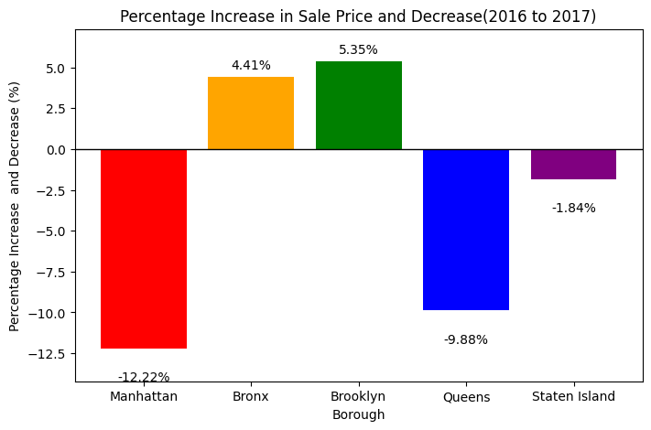

Figure 7: Percentage Increase and Decrease in Sale (2016-2017)

The contrasting trends between boroughs might reflect changing demographics, with younger buyers and families increasingly seeking more space and better value in areas like Brooklyn and the Bronx. This pattern of price changes indicates a possible market rebalancing, where Manhattan's premium pricing reached a ceiling while more affordable boroughs attracted increased buyer interest. The decline in Manhattan prices could also be attributed to several other factors, including rising interest rates affecting luxury buyers, changes in tax laws impacting high-end real estate, and a potential shift in international buyer sentiment. The significant drop in Queens might also reflect the impact of new development projects flooding the market with inventory, particularly in areas like Long Island City and Flushing. On the other hand the positive growth in Brooklyn and the Bronx demonstrates these boroughs' resilience and growing appeal, supported by improved infrastructure, new commercial development, and better transportation options. The relatively small decline in Staten Island suggests its unique market position as a more suburban option within New York City helped insulate it from more dramatic price swings. These price trends might also indicate a broader shift in New York City's real estate landscape, where traditionally less expensive boroughs are gaining more attention from developers and investors looking for new opportunities.

The bar chart below illustrates the average sale price of properties in each borough of New York City, highlighting significant differences in real estate values. Manhattan has the highest average sale price at $3,337,951, significantly surpassing the other boroughs, which suggests a high demand for luxury properties and premium locations. Brooklyn follows with an average price of $834,488, reflecting its increasing popularity due to its blend of historic neighborhoods and modern developments. Queens, with an average sale price of $739,909, is also experiencing growth, likely due to its expanding residential communities and proximity to Manhattan. The Bronx and Staten Island have the lowest average sale prices, at $590,194 and $543,472, respectively, making them more affordable options for buyers.

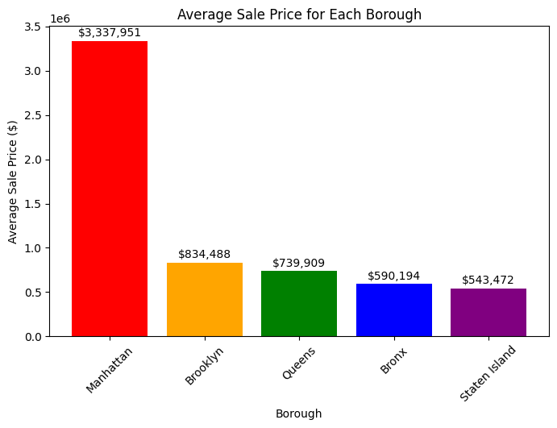

Figure 8: Average Sale Price for Each Borough

The steep price difference in Manhattan suggests that it remains the most exclusive and in-demand real estate market, attracting high-income buyers and investors. Brooklyn and Queens, while more affordable, still show strong property values, indicating continued growth and gentrification in certain areas. The Bronx and Staten Island, though lower in price, offer significant opportunities for homebuyers seeking more space and lower costs, potentially making them prime areas for future investment.

**Median vs Average Sale**

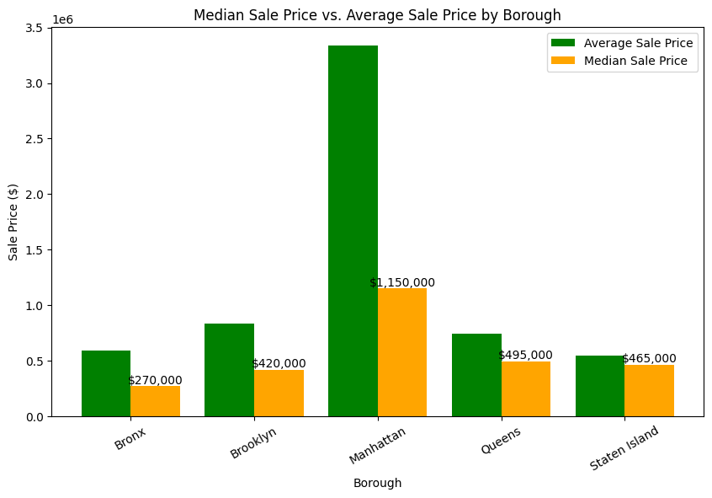

Figure 9: Median Sale Price vs Average Sale Price by Borough

The bar chart compares the median and average sale prices across different boroughs, highlighting the disparity in property prices. Manhattan has the highest average sale price, exceeding $3 million, while its median sale price is significantly lower at $1.15 million. This gap indicates the presence of ultra-high-value properties that skew the average upward, making the median a more representative measure. The Bronx, Brooklyn, Queens, and Staten Island show a smaller difference between their average and median sale prices, suggesting more uniform property values. Brooklyn and Queens have similar price distributions, while the Bronx and Staten Island show the lowest overall prices. The median sale price is often used instead of the average because it better reflects the typical market conditions by eliminating the impact of extreme values. A few high-end luxury sales in Manhattan can raise the average disproportionately, misleading potential buyers or analysts. The median, being the middle value of all transactions, provides a clearer picture of what most buyers are actually paying. It is especially useful in real estate markets with wide price ranges, as seen in Manhattan. Overall, the comparison between average and median sale prices helps in understanding price distribution and market affordability in different boroughs.

**Monthly Sale Trend (Seasonal Trend Sales)**

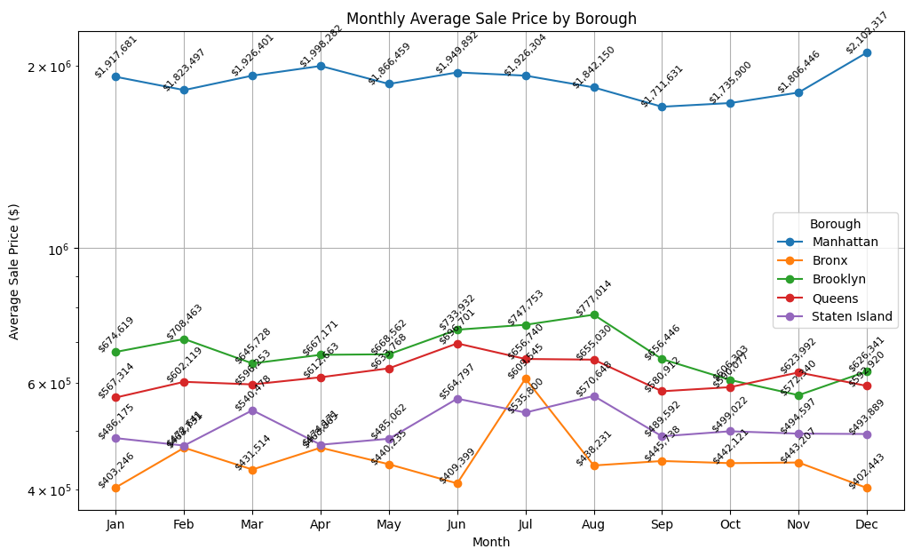

Figure 9: Median Sale Price vs Average Sale Price by Borough

The monthly average sale price trends in New York City reveal seasonal fluctuations that vary across boroughs, reflecting changes in market demand, economic factors, and seasonal buyer behavior. Manhattan, the borough with the highest property values, remains relatively stable throughout the year, with prices ranging between $1.8 million and $2.1 million. A significant peak occurs in December, possibly due to year-end transactions, tax considerations, or an increase in high-value property sales. Brooklyn and Queens display moderate fluctuations, with Brooklyn peaking in August and Queens experiencing a steady rise until mid-year before stabilizing. The Bronx shows more volatility, particularly in July when sale prices see a sharp spike, which could indicate a surge in demand or a few high-value sales skewing the average. Staten Island also demonstrates a gradual upward trend with some month-to-month variations. The summer months—especially June and July—tend to see higher prices, likely due to increased buyer activity when families prefer to relocate before the school year begins. Conversely, a dip is observed in September and October, suggesting a seasonal slowdown, followed by a recovery in November and December. External factors such as mortgage rate fluctuations, inventory levels, and economic conditions could also play a role in these pricing trends. Overall, New York City’s real estate market follows predictable seasonal trends, with summer spikes and a December rebound indicating increased market movement during these periods.

**Old vs New Building Across New York**

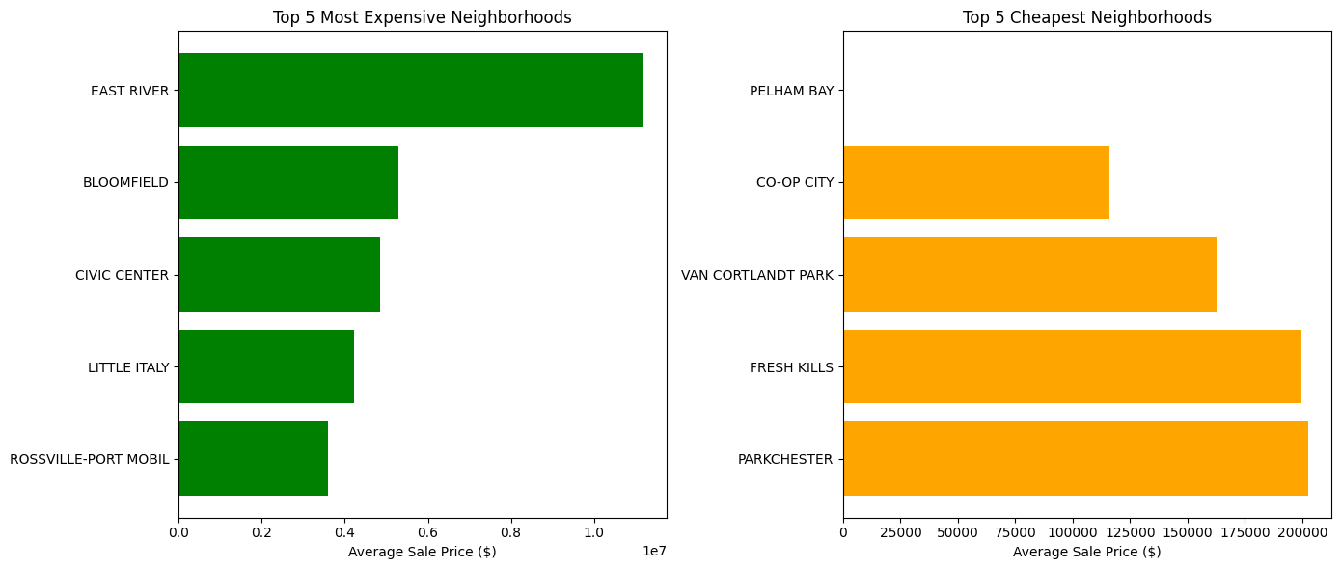

Figure 10: Top 5 Most Expensive and Cheapest Neighborhoods

The real estate market in New York City showcases a stark contrast between the most expensive and cheapest neighborhoods. The most expensive neighborhood, East River, has significantly higher property prices, surpassing $10 million on average, making it a hub for luxury real estate. Other costly areas, such as Bloomfield, Civic Center, Little Italy, and Rossville-Port Mobil, also feature high-value properties, likely due to prime locations, historic significance, and limited housing supply. These areas attract wealthy buyers, investors, and businesses looking for exclusivity and proximity to economic centers. On the other hand, the most affordable neighborhoods, such as Pelham Bay, Co-Op City, and Van Cortlandt Park, offer properties with significantly lower price tags, averaging below $200,000. These neighborhoods, often located in the Bronx and Staten Island, provide budget-friendly housing options, making them ideal for first-time homebuyers and middle-income families. Factors such as accessibility, infrastructure development, and neighborhood amenities play crucial roles in shaping these price differences. The affordability of these areas suggests a strong rental market and a potential for future appreciation as city expansion continues. The disparity between the most and least expensive neighborhoods highlights the economic diversity of New York City’s real estate market. While luxury markets cater to high-net-worth individuals, lower-cost neighborhoods offer attainable housing options for the broader population. These trends reflect both the exclusivity and accessibility aspects of the city’s dynamic housing landscape.

**Consumer Preference**

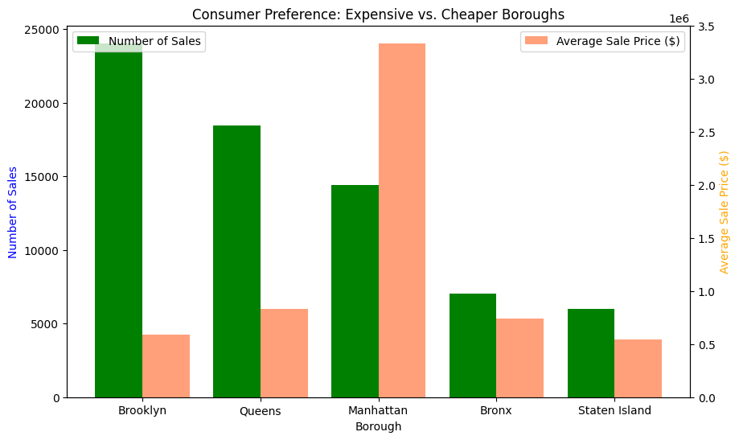

Figure 11: Consumer Preference: Expensive vs. Cheaper Boroughs

Brooklyn and Queens have the highest number of sales despite having lower average sale prices, suggesting that consumers are more inclined toward **affordability** and prefer boroughs with **lower prices but higher transaction volumes**. In contrast, Manhattan has the highest average sale price by a significant margin, yet its number of sales is lower than Brooklyn and Queens. This indicates that while Manhattan properties are the most expensive, they attract fewer buyers, possibly due to affordability constraints. The Bronx and Staten Island show a balance between affordability and demand, with lower sale prices and moderate transaction volumes. These boroughs appeal to buyers looking for more affordable options compared to Manhattan, but they still see fewer sales compared to Brooklyn and Queens. Overall, the data suggests that consumers prioritize affordability over luxury, leading to higher transaction volumes in boroughs with lower prices.

**Gross Square Feet and It’s relation to consumer choices**

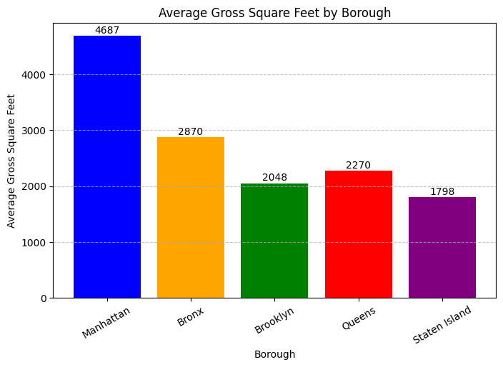

Figure 12: Average Gross Square Feet By Borough

Gross square feet (GSF) is a crucial factor in determining a buyer’s choice when selecting a property. Larger spaces often come with higher price tags, especially in Manhattan, where properties boast significantly higher GSF, justifying their premium prices. On the other hand, Brooklyn and Staten Island offer smaller homes that are more affordable, making them attractive to budget-conscious buyers. There is also a trade-off between affordability and space, as boroughs like Queens and Brooklyn provide a balance with moderate square footage at lower prices, appealing to those who prioritize cost over size. The type of buyer also plays a role, as families seeking spacious homes may gravitate toward the Bronx or Staten Island, while investors and luxury buyers are drawn to Manhattan’s prestigious, high-GSF properties. Additionally, GSF reflects the urban density of each borough, with Manhattan dominated by luxury apartments and commercial spaces, whereas the Bronx, Brooklyn, and Queens have a mix of apartments and single-family homes. Staten Island, having the lowest GSF, aligns with its suburban housing market. Moreover, properties with larger square footage tend to have higher resale value and rental potential, making them attractive for long-term investments. Manhattan’s high GSF attracts wealthier buyers willing to pay for luxury, while other boroughs cater to middle-class buyers who prioritize affordability. Ultimately, GSF plays a significant role in shaping the housing market, influencing demand based on location, budget, and investment potential. Buyers must decide whether they prefer more space for their money or are willing to pay a premium for a prime location.

**Trends & Insights:**

The analysis of NYC’s real estate market reveals significant borough-wise variations in property prices and trends from 2016 to 2017. Manhattan remains the most expensive borough, with an average sale price exceeding $3.3 million, highlighting its dominance in luxury real estate. In contrast, Brooklyn and Queens demonstrate stable growth and affordability, making them popular choices for buyers. While Brooklyn experienced a steady increase in sale prices, Queens and Staten Island saw declines, possibly due to market saturation and shifting buyer preferences. The Bronx emerged as an attractive, affordable alternative, showing positive price appreciation. Additionally, seasonality plays a crucial role in pricing trends, with peaks observed in summer and year-end months. The disparity between median and average sale prices underscores the impact of high-end property sales, particularly in Manhattan, which skews the average upward.

**Limitations & Challenges:**

Despite offering valuable insights, the dataset has several limitations. Missing apartment numbers and inconsistent tax class data pose challenges in achieving complete accuracy. The presence of extreme outliers, particularly in Manhattan, can distort trends and necessitate careful data preprocessing. Additionally, external factors such as economic conditions, tax law changes, and foreign investment fluctuations influence market trends but are not directly accounted for in the dataset. The absence of rental price data and mortgage rate influences further limits the scope of this analysis. These challenges highlight the need for supplementary datasets and advanced modeling techniques to refine real estate market predictions.

**Recommendations:**

To enhance decision-making, real estate stakeholders should focus on borough-specific market trends and identify emerging investment opportunities in high-growth areas like Brooklyn and the Bronx. Developers should consider increasing affordable housing projects in boroughs with rising demand. Further research should incorporate external economic factors such as interest rates and employment trends to better predict market shifts. Additionally, leveraging machine learning models for predictive analysis can provide deeper insights into future price movements and buyer preferences.

**Conclusion:**

The NYC real estate market exhibits dynamic trends, with significant variations across boroughs. While Manhattan retains its premium market status, Brooklyn and the Bronx present growing investment potential. The dataset provides valuable transparency but also highlights the need for more comprehensive data integration to fully understand market behaviors. By refining data analysis approaches and considering external market drivers, real estate professionals and policymakers can make informed decisions to foster sustainable growth and equitable housing opportunities in New York City.